Emerald coast music~  
lessons options

For Aspiring Musicians

# Overview

EMERALD COAST MUSIC LESSONS offers a wide variety of teaching techniques tailored to individual learning styles. Using these tailored teaching methods, we teach our students how to play an instrument or instruments at their desired level of performance ability.

## Available Lesson Plans for 2022/23

* **Piano**: Intro, beginner, intermediate, advanced
* **Acoustic** **Guitar**: Intro to acoustic, intermediate acoustic guitar, advanced acoustic guitar
* **Bass Guitar**: Intro and intermediate bass guitar
* **Electric Guitar**: Intro and intermediate electric guitar
* **Voice**: Intro, intermediate, and advance vocal lessons
* **Ukulele**: Intro and Intermediate ukulele
* **Transition**: From any instrument to acoustic guitar or piano
* **Integrated Classes**: Mixing and matching multiple instruments within the chosen class length

## Learning Venue

Emerald Coast Music provides excellent service in a fully equipped music studio. You may choose to have your lessons recorded every time, or periodically to track your progress. Only the student will be allowed to be in the lessons room unless your child is the student, in which case you may stay until you are comfortable leaving your child for their sessions. Please remember this time is reserved for the student to learn. Phones must be silenced. Distractions will only hinder you or your child’s learning process. Please arrive only at the time you have agreed to. **If you arrive early, you must remain in your vehicle until the exact time your lesson begins**, as to not disturb the student before you.

## Learning Materials

* Instrument: The student must own and maintain their instrument of choice.
* Syllabus: The student will be receiving a detailed learning plan that will guide them through the process.
* Reading materials: The student will get recommendations on what books (if any) will help them through the learning process according to the instrument of choice.
* Video materials: YouTube and other various visual aids may be recommended according to the instrument of choice.

# sCHEDULING

There are two different sessions students can choose from in terms of length of time. Longevity should be carefully considered as to not overwhelm the student with too much information at once. Children under the age of 8 are automatically recommended 30 minutes.

## Session Lengths

* 30 minutes
* 60 minutes

## Scheduling Appointments

Typically schedule your session a week in advance to assure your desired spot. It is generally best to choose a day of the week that will work for you each week. You will schedule a time slot that will be dedicated to you weekly without having to call each time. You may schedule more than one session per week if you wish. Your instructor will recommend session lengths and frequency after meeting with you on the first session. Payment is due before or at the beginning of your first session. Students are required to pay by the month in order to ensure your class time, and to show a level of commitment. This is not negotiable, and non-refundable. 30 day notice is required upon discontinuation of lessons. Please give your instructor ample time to prepare if you plan on withdrawing. There will be months that will have 5 of your timeslots instead of 4. When this occurs, (usually 4 times per year) your instructor will tell you which week to take off, or you may pay for the additional lesson.

## Cancelling Appointments

If you are unable to keep your scheduled appointment, kindly give a minimum of **24 hour notice**. You will not be charged any kind of fee for cancellation, and you will be able to schedule a makeup lesson. If notice is given 24 hours or less prior to a scheduled lesson, a $5 scheduling fee will be implemented in order to schedule a makeup lesson, or you may choose to forfeit the lesson without a fee. In the event of a no call/ no show, the lesson is lost without refund. Payment for the following cycle is due upon the completion of your final lesson or **NO LATER THAN THE 1ST** of the month, whichever comes first, to ensure your time slot. If you or your child are sick with a contagious illness, schedule a Makeup Lesson immediately. Do not come if you are sick!

## Makeup Lessons

Not all instructors issue makeup lessons. We however do, but restrictions do apply. If your absence fit the criteria listed above, you may be issued a makeup lesson. Makeup lessons will be scheduled when your instructor’s schedule will allow, along with your schedule. Makeups do not expire, but will cap after 4 have accumulated at any given time. Makeups may NOT be scheduled during a regularly scheduled timeslot. This includes months with 5 weeks. You may NOT schedule a makeup lesson for a day during a month that has not been paid for. **Please understand that you have been sold a weekly timeslot, whether or not you come, much like a membership to a gym. Therefore, makeup lessons will ultimately be issued at the discretion of your instructor.**

## 

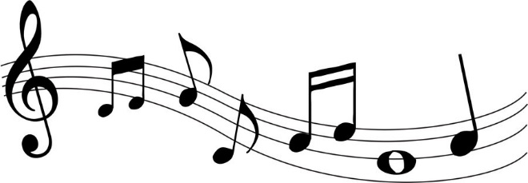

**Pricing**

Factors that determine price include instrument of choice, and length of session. We do offer “home schooling” lessons, however travel charge will be included in monthly tuition. Integrated classes are also available.

**LESSONS ARE CHARGED ON A MONTHLY BASIS**

|  |  |  |
| --- | --- | --- |
| Instrument | 30 Minute Session | 60 Minute Session |
| Piano | $120/Month | $160/Month |
| Acoustic Guitar | $120/Month | $160/Month |
| Ukulele | $120/Month | $160/Month |
| Electric Guitar | $120/Month | $160/Month |
| Bass Guitar | $120/Month | $160/Month |
| Voice | $120/Month | $160/Month |
| Integrated Classes (Multiple Instr.) | $120/Month | $160/Month |

## Payment Methods- Cash and *VENMO* are accepted. You will be billed by the 25th of every month. Please be sure that your payment is in NO LATER THAN the 1st of every month as to not lose your time slot. If you are not using Venmo, you are advised to pay on the final lesson of the month as to not be late. If payment is made later than the 1st without an arrangement, a 25$ late fee may be applied.

# Instructors

|  |  |
| --- | --- |
| Jeremy Umbenhower | All instruments listed above |
| **Rebecca Umbenhower** | **Piano and Voice** |
| **Affiliate Instructor: Selene Hunter** | **Piano** |

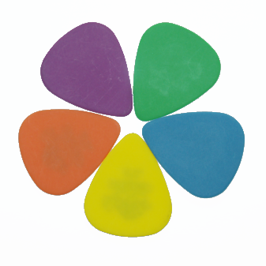**EMERALD COAST MUSIC LESSONS Initial Intake Form**

Name:__________________________________ Date :_____/_____/_____

Email Address:_______________________________________@_________________.com

Previous music experience (if any)______________________________________________

**Phone Number:**

__________________________________________________________________________

Instrument (circle) **Piano Acoustic Guitar Electric Guitar Bass Guitar Voice Uke**

Will you be transitioning from another instrument? **Yes No**

Start date ______/______/_______ Agreed time slot: _____:_____

Day of week agreed upon (circle multiple days if you wish to have more than one lesson per week)

**Saturday Sunday Monday Tuesday Wednesday Thursday Friday**

Session Length Selected (Circle) **30min 60min**

Instructor’s signature __________________________________________________________

Student’s signature_________________________________Date________________________

By signing this document, you are agreeing to the terms and conditions of makeup lessons and all other articles listed in the intake form. You are also acknowledging that lessons are not eligible for refund outside the expressed consent of your instructor. This document must be completed and signed before any further lessons are scheduled. Please keep a copy of this form for your records.